Track Record (“TR”) Automation
Installation Instructions – GitHub/Excel VBA and Python

1. What you need on your computer to run this program
- Microsoft Excel (Windows or Mac) able to run macros.
- Python 3.10 or newer.
- Internet access once, for the first-time setup. After that, the app works offline.

2. Steps to Download and Run the TR Analyzer for the 1st Time

Step 1 – Downloading the TR Analyzer VBA from GitHub
- Open the team's private GitHub repository and switch the branch selector (top-left) to vba. This is the link -> https://github.com/jjjane-wu/Track-Record-Analyzer/tree/vba
  - Main File Contents to Be Aware Of
    - start.bat -> application launcher for Windows. Click this to open the TR Automation Tool
    - vba/TR-Analyzer.xlsm – this is the VBA code that enables the TR Automation

- Click the green Code button → Download ZIP. (Or ask the maintainer for the ZIP directly.)

- Before extracting: right-click the downloaded ZIP → Properties → tick Unblock → OK. This clears Windows' "downloaded from the internet" flag; skipping it is the #1 reason Excel later refuses to run the macros.

- Extract the ZIP anywhere you like — Desktop, Documents, and OneDrive folders are all fine.

Step 2 – Downloading Python for your Laptop
- Install Python from https://www.python.org/downloads/windows.

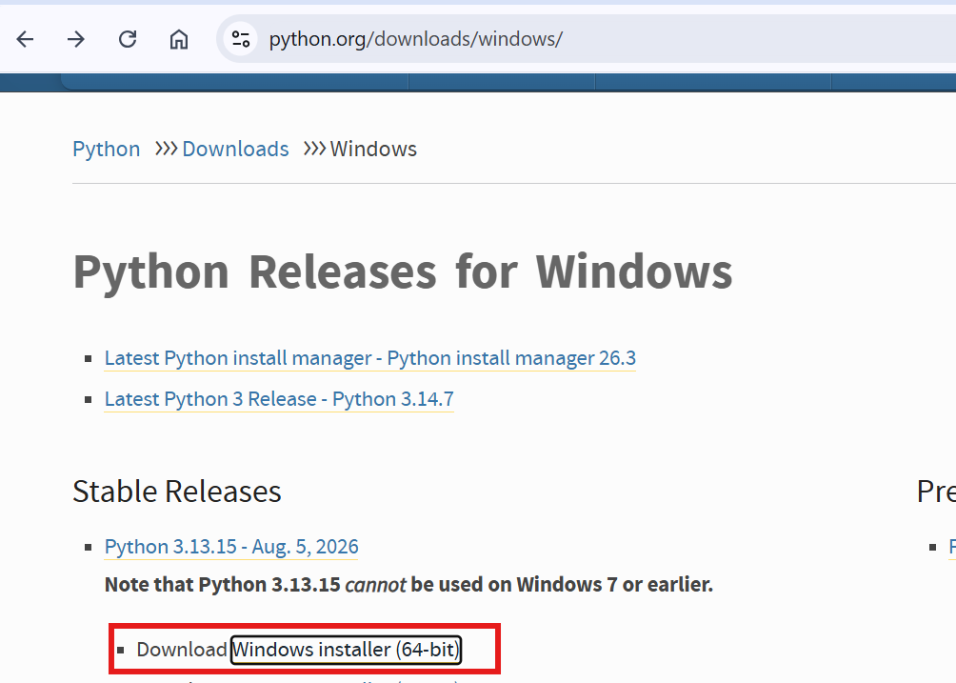

- Open the download exe file you just downloaded. On the very first installer screen, tick “Add python.exe to PATH”.

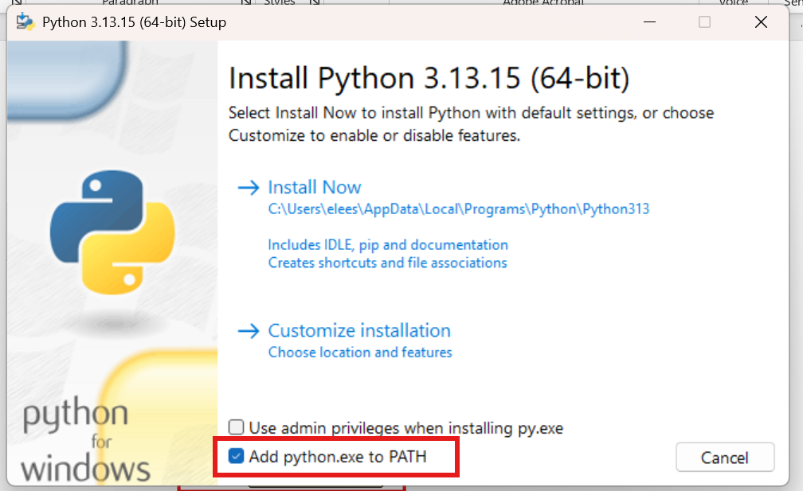

- Double-click the launcher: start.bat, located in the TR Analyzer VBA zip file you extracted during Step 1. On a Mac, double-click start.command instead, and click Enable Macros when Excel asks later on.

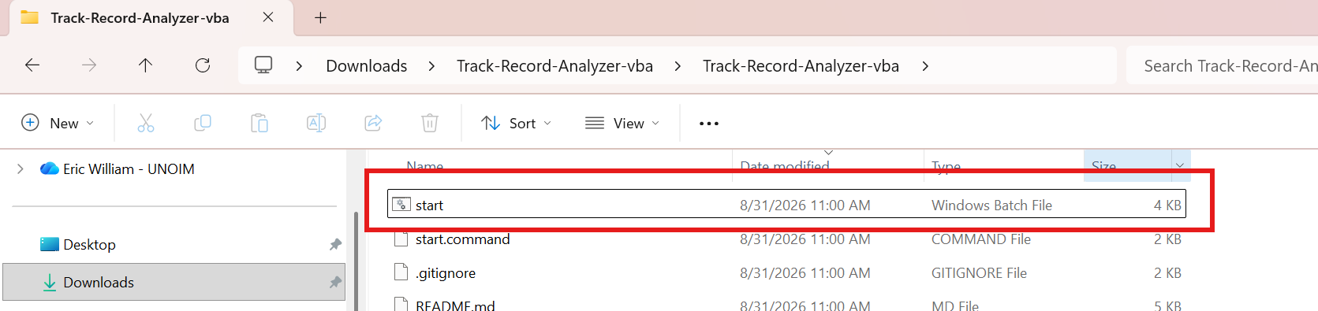

- The first run creates the app's private environment and installs its components — a few minutes, once. Afterward, the app starts in seconds. The first time, the screen will stay on this for a few minutes; do not close the command window

At first it will look like this….

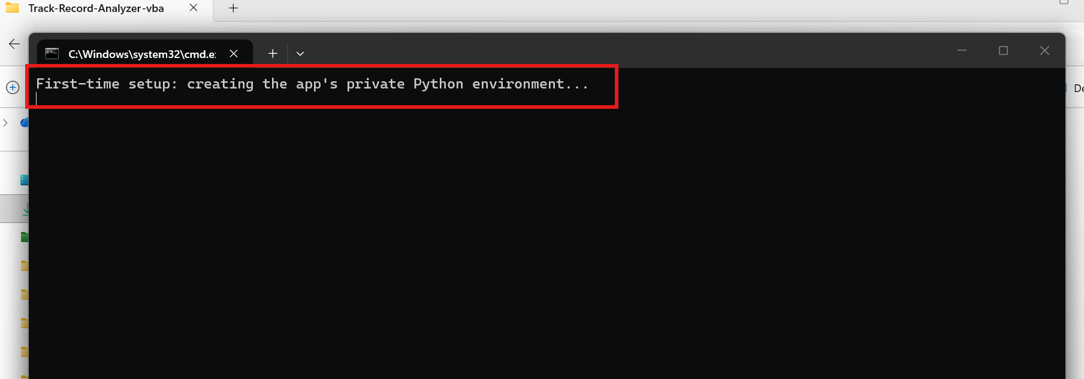
Then it will start looking like this…
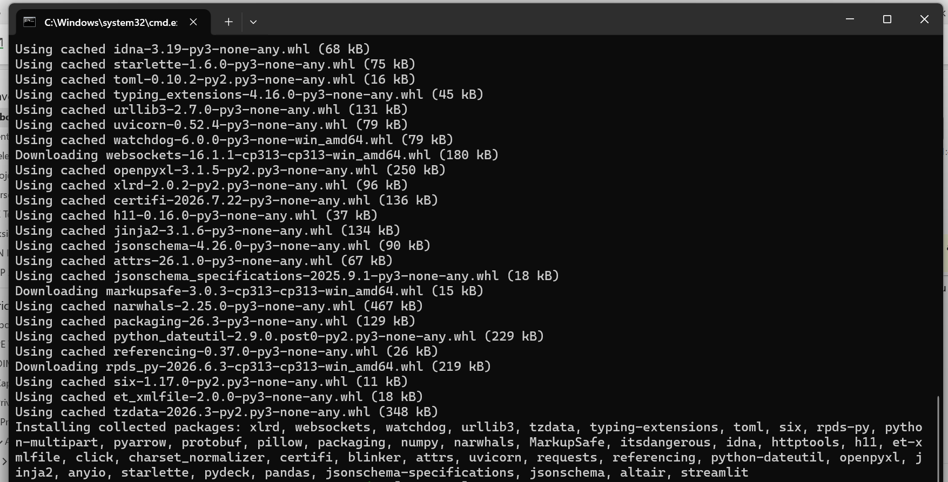

And finally it will look like this before launching in your web browser
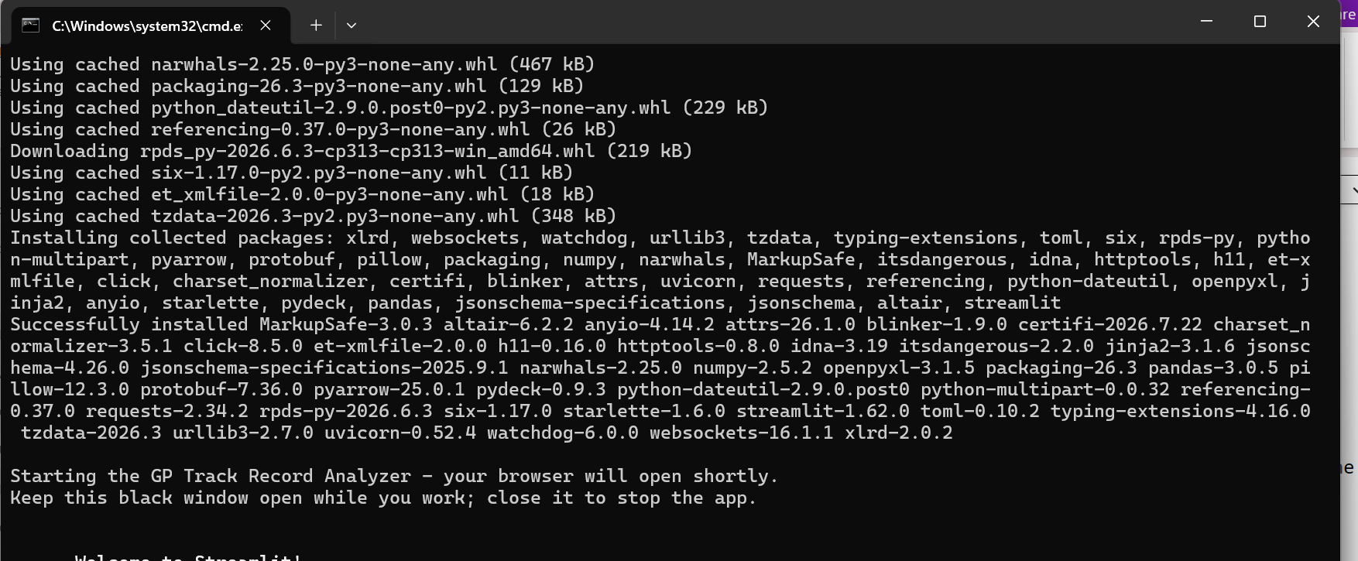

- Once it is done loading, hit Enter on your keyboard. If you have an issue, then close and relaunch; it will not take as long to load.
The landing page looks like this. If you see this page, you are done installing!
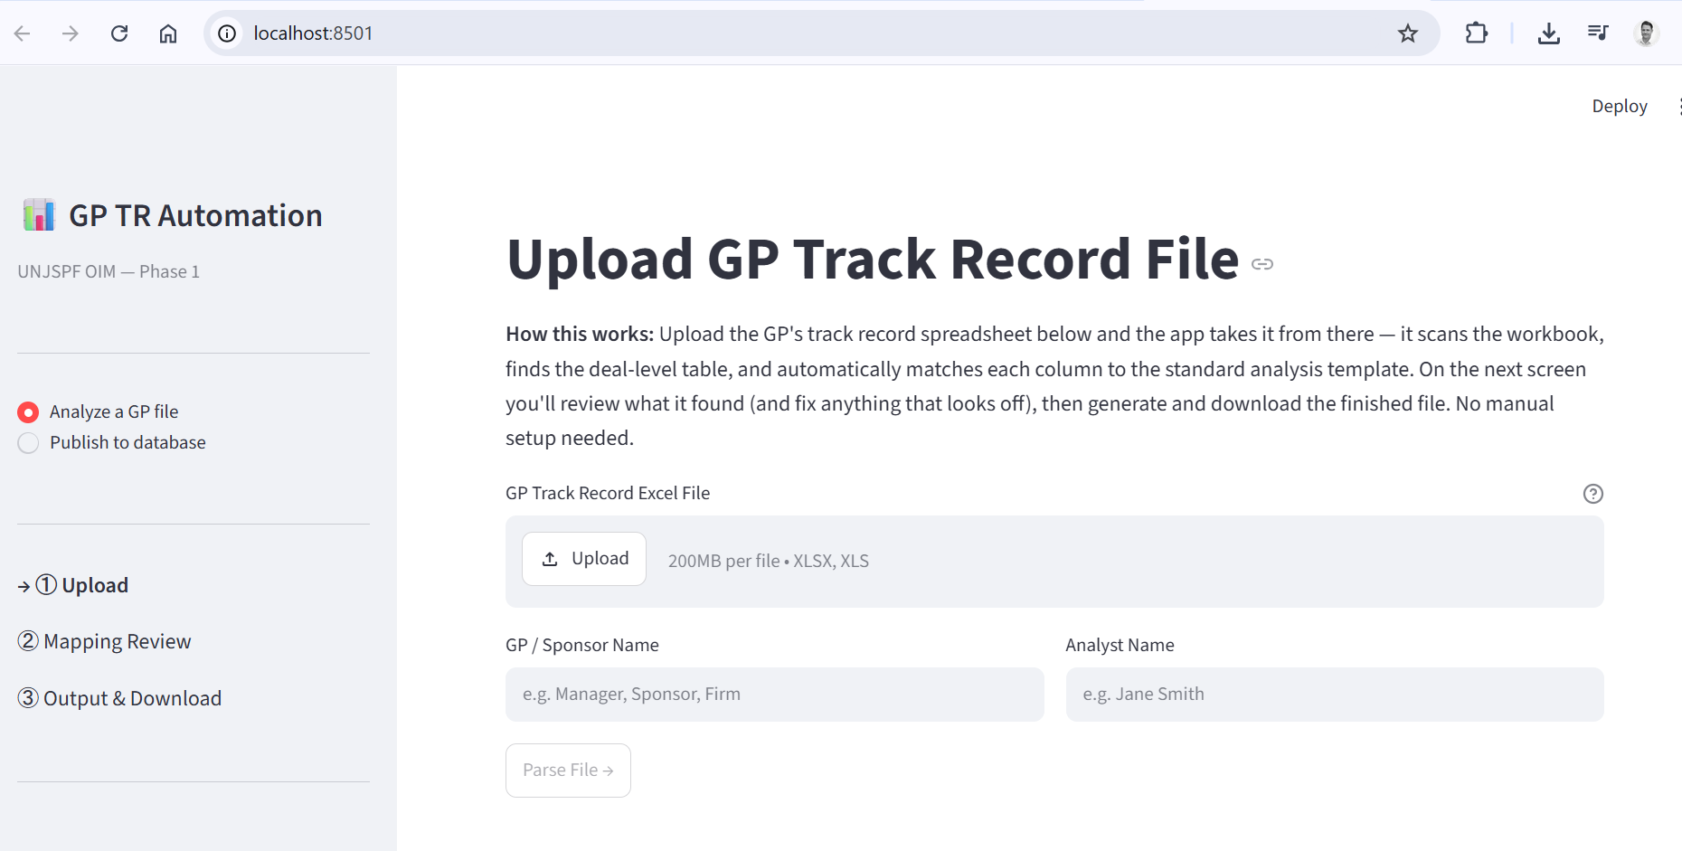

3. Troubleshooting
Excel says “Because of your security settings, macros have been disabled.”
The workbook still carries Windows’ downloaded-file flag, or you changed the macro settings while the file was open. Close the workbook, right-click TR-Analyzer.xlsm (or, better, the ZIP before extracting) → Properties → tick Unblock → OK, then reopen it and click Enable Content. Trust Center changes only take effect after the file is reopened.
A red banner says “Microsoft has blocked macros because the source of this file is untrusted.”
Same cause, same fix: Unblock the file (or the ZIP) and reopen. If Properties shows no Unblock box or the banner keeps coming back, your organization’s IT policy is blocking internet-sourced macros — add the extracted folder under File → Options → Trust Center → Trusted Locations, or ask IT to whitelist the folder.
Running the macro stops with “Compile error: Sub or Function not defined.”
Your analyzer workbook is from an older download. Download the latest ZIP from the vba branch and use the vba/TR-Analyzer.xlsm inside it.
The black window says “‘python’ is not recognized as an internal or external command.”
Python was installed without “Add python.exe to PATH”. Re-run the Python installer and tick that box on the first screen (see Step 2), then double-click start.bat again.
The first launch looks stuck for a long time.
The first run creates the app’s private environment and downloads its components — a few minutes is normal, and it happens only once. It needs internet that one time; on an office network a proxy can block the download — try another network, or ask the maintainer for a copy with the environment pre-installed.
The black window asks for an email address.
Press Enter to skip it — it is a one-time prompt from the app framework, nothing is sent.
The browser never opens.
Leave the black window open, open your browser yourself and go to http://localhost:8501.

